Описание фотографии
Выберите фотографию и опишите человека на ней. У вас есть полторы минуты на подготовку и не более двух минут для ответа. У вас должен получиться связный рассказ (7–8 предложений).

План ответа поможет вам:
— the place;
— the action;
— the person’s appearance;
— whether you like the picture or not;
— why.
Start with: “I’d like to describe picture one (two, three). The picture shows …”
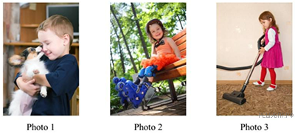

Пояснение.
I would like to describe picture one.
The photo shows a boy. He is obviously at home. He is holding a dog in his arms. The dog is licking the boy's face. The boy is wearing a dark blue T-shirt. He seems to like his dog.
I like the photo because I just love pets.

